[www.globalspecialeffects.com](http://www.globalspecialeffects.com)

*

*

*•

*

•

:t

;,\(.

*

*.•

•

·*

**MANUAL**

**USER**

**INCREDIBLE**

**THE**

256.229.5551 I 24/7 TECH SUPPORT: 888.391.7669



Important Product & Safety Information: **Failure to follow these instructions could cause serious bodily injury or property damage. These instructions pertain to a risk of fire, electric shock or injury to persons.**

**Warning: You must read the following before operating this device.**

2

Save these directions.

* **Never operate the Snowman without liquid solution SMF-1C & water, in the machine tank. Do not operate the Snowman when the machine tank contains a pint or less of solution. If you do not follow these directions, the device may be damaged.**
* Always operate the Snowman on a dry, even surface away from a ledge or steps to prevent any falling hazards or slippery conditions.
* Never leave the device unattended while operating. Do not operate in the rain or near standing water.
* Always use an outlet with an earth grounded receptacle and a ground fault circuit interrupter
* (GFCI.) Never operate the device with a grayed electrical wire. Do not use in extreme heat or cold.
* Never use this product for any activity other than it was designed for.
* Stir the solution in the container before operating the Incredible Snowman.

This device sprays evaporative snow that dissipates easily when sprayed from 15 to 20 ft. in the air. The

snowman may be positioned at ground level; however there is a chance for some build-up of slippery residue on some ground surfaces (linoleum in particular.) Use caution in determining the locations for the Incredible Snowman and warm passers-by of potential slippery conditions.

The Incredible Snowman is an electrical product, not a toy. To avoid the risk of fire, burns, personal

injury and electric shock, **it should not be used in a manner for which it was not designed and should be placed out of reach of small children.** Competent adult supervision is necessary to avoid the risk of electric shock or personal injury.

The Incredible Snowman is recommended for outdoor usage.

The Incredible Snowman is a home version of the special effects machines used for years in movie

productions, theaters, malls and high end exhibits. The Incredible Snowman sprays specially formulated evaporative snow and creates a unique snowfall effect without cold air or cleanup required. This device can be the centerpiece of outdoor holiday arrangements in almost any environment.

[www.globalspecialeffects.com](http://www.globalspecialeffects.com)



70 in

Cable Length:

1.5-2 oz. Solution Mixture per minute (approximate)

Snow Solution Usage Rate:

ABS, PSA, & PE

Materials:

27 lbs.

Weight:

20” x 20” x 34” (l, w, h)

Size:

10 Amps

Fuse:

120v 60Hz

Voltage:

3

1. Always prepare your snowfall area; making sure it is dry and free of obstructions. Note that if

the snowfall surface area is linoleum or smooth, the floor may become slippery.

2. Locate the snowman on a secure, dry, and level surface then rotate the snowman so that the desired direction of snowfall is achieved. Keep the snowman unplugged from the electrical outlet while placing the snowman in your desired location. Do not operate the snowman from a wet surface.

General Operating Instructions:

In order to create a beautiful and entertaining evaporative snowfall, ensure the safety of the operators/participants and protect the equipment from damage. Please follow these instructions carefully.

To reduce the risk of electrical shock, do not put the snowman in water or other liquids. Do not

place or store the appliance in a location that is damp, wet or near water.

6.

To disconnect, turn all controls to the off position, then remove plug from the outlet.

Do not unplug by pulling on the cord. To unplug, grasp the plug, not the cord. Unplug from outlet when not in used and before servicing or cleaning.

Do not operate any appliance with a damaged cord or plug, after the appliance malfunctions, is dropped or damaged in any manner. Seek evaluation at the nearest authorized services facility for repair or electrical or mechanical adjustment.

a.

b. c. d.

Read all instructions before using the appliance

To reduce risk of injury, close supervision is necessary when an appliance is used near children. Do not make contact with moving parts during operation.

Only use attachments recommended or sold by the manufacturer. For a cord-connected appliance, the following shall be included:

1.

2.

3.

4.

5.

**Warning:** When using electric appliances, basic precautions should always be followed, including the

following:

[www.globalspecialeffects.com](http://www.globalspecialeffects.com)



8.

Turn the cap to the container in a clockwise direction and tighten.

In order to start the snowman simply press the red button on the side of the unit to the “I” or open position and your snowman will start (allow ~30 second for the pump to prime and for snow production.)

If the solution has drained out of the clear tube during a rest period for the Snowman, it may take ~1-2 minutes for the pump to self-prime the solution from the container liquid.

There is a control switch above the power switch of the snow machine that allows you to adjust

the snowfall amount. The snow should come out in a light flurry in order to evaporate properly. A heavier snowfall will tend to accumulate on the ground causing slippery conditions.

If the snow is not generating properly after several uses, remove the snow sock on the top of

the machine be removing the plastic tic [zip-tie] and rinse under warm water and replace (using new plastic tic [zip-tie] provided.)

**Remember; do not let the machine run with a very low or empty tank as this can damage the pump. The pump does not shut off automatically.**

4

7.

6.

4.

5.

Prepare the snow solution in the plastic container built in. (See: image below.) Fill the container

with water using the included funnel. Then add one 3oz of snow solution concentrate. If the water/concentrate is not blended properly, the snow machine will not create the ideal evaporative snowflakes.

3.

[www.globalspecialeffects.com](http://www.globalspecialeffects.com)

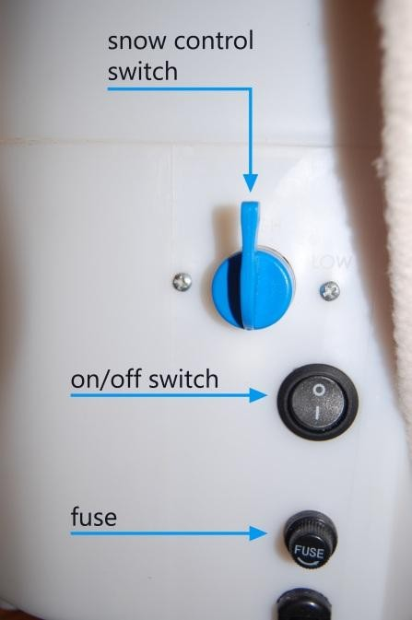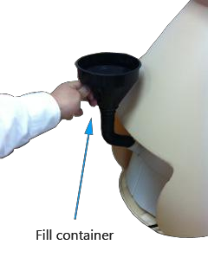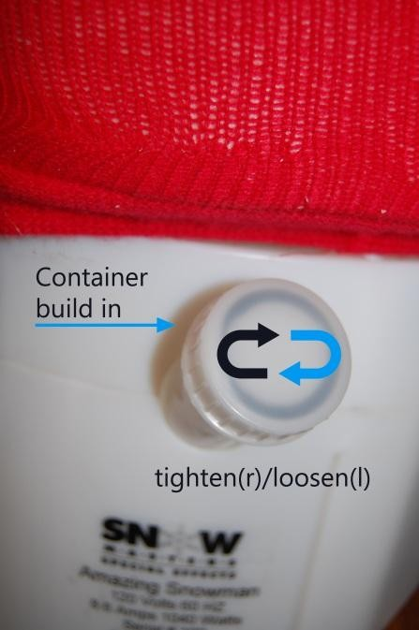

Insure that the snow fluid is mixed in the proper ratio.

Poor quality snow

Insure that the proper mixture of fluid is in the reservoir and that the reservoir is full.

Turns on, but does not make snow – pump is noisy

Insure that the correct power is applied to the snowman

Snowman isn’t turning on

5

*If you have problems with your snow machine operation, please call (00-1) 256.229.5551 for 24*

*hour technical support.*

Troubleshooting:

Storage:

Store the snowman in its plastic bag and box, if possible. Do not stack other boxes or items on top of the

Snowman; store in a cool, dry environment between 40-80 degrees Fahrenheit.

Operation and User Maintenance:

Surface clean only, with a damp cloth.

9. Do not operate at temperatures below 25 degrees Fahrenheit.

10. Warning: To reduce the risk of electrical shock, unplug before cleaning or servicing.

[www.globalspecialeffects.com](http://www.globalspecialeffects.com)

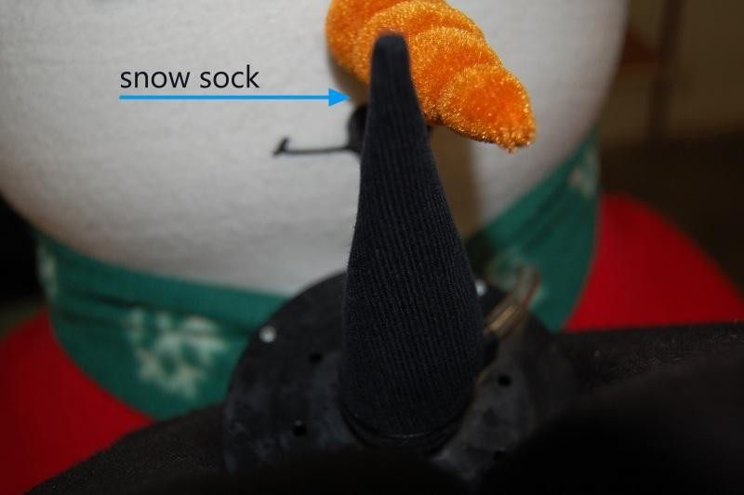

6

Limited One Year Warranty

The Snowman is covered by a limited ONE-YEAR warranty for manufacturing defects related to the power cord, pump and fan when used in non-commercial application. Any misuse, abuse, or negligence automatically voids our warranty. The use of any liquids or materials other than water and approved Global Special Effects solutions automatically voids this warranty. Global Special Effects is not responsible for incidental or consequential damages and liability is limited to repair or replacement of the Snowman at Global Special Effects’ sole discretion. Global Special Effects is not responsible for physical damage, scratching, tube damage, after shipping from Global Special Effects’ manufacturing facility. This warranty excludes all costs of shipping and related expenses.

[www.globalspecialeffects.com](http://www.globalspecialeffects.com)

