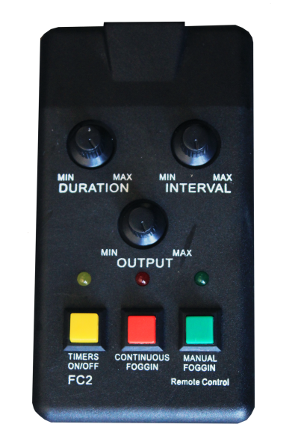
Introduction:
Thank you for choosing the COLD-FLO Fog Machine. You now own a rugged and powerful state-of-the-art machine. Prior to use, we suggest that you carefully read all of the instructions. By following the information found in this user manual, you can look forward to the reliable and satisfactory performance of your COLD-FLO machine for years to come.
Please follow these operating, safety, and maintenance instructions to ensure a long and safe life for your COLD-FLO Fog Machine..
-Ideal operating temperatures are 38 – 98 degrees Fahrenheit.
-After interruption of operation, wait three minutes before starting again.
-Keep the unit dry.
-Do not tilt this device to an incline of more than 30 degrees.
-Turn off or unplug when not in use.
-This machine is not water-proof. If moisture, water, or fog liquid gets inside the housing, immediately clean the unit before using it again.
-No user serviceable parts inside. Refer to your dealer or other qualified service personnel.
-For adult use only. COLD-FLO Fog Machine must be installed out of the reach of children. Never leave the unit running unattended.
-Locate the fog cooler in an enclosed area. Never cover the unit’s vents. The fog cooler is best installed 3 feet away from all objects.
-Only use Fog Master Chiller Fog Fluid.
-If COLD-FLO Fog Machine fails to work properly, discontinue use immediately. Pack the unit securely (preferably in the original packing material) and return it to your dealer for service.
Information:
Heat up time: 15 minutes
DMX512 signal
Voltage: 220v 50-60hz
Heater: 5000W
Output: 30,000cu.ft/min
Size 35.5x24x16.6
Weight: 199 lbs.
Wire Control:
1. The machine is ready for use when the green indicator light is on. By pressing the green button, the machine will generatefog, but will cease when release the green button.
2. When the green and red indicator lights are on, the machine can spray continuously when pressing the red button.
3. When the green and yellow indicator lights are illuminated, you can setup the duration, interval, and output.
Unpacking & Inspection:
1. Open the shipping carton and verify that all equipment necessary to operate the system has arrived intact.
2. Before beginning, initially setup the COLD-FLO Fog Machine, make sure that there is no evident damage caused by transportation. In the event that the unit’s housing or cable is damaged, do not plug it in and do not attempt to use it until after contacting your dealer for assistance.
Operation:
1. Remove all packing materials from Flight-cases. Check that all foam and plastic padding is removed.
2. There are two lines on the back of fog machine. (One is for the fog machine; the other is for the cooler.) Plug power cord into a grounded 220v electrical outlet. Turn the red power switch onrear unit to the “ON” position this starts the fog machine heating up. The heat up time is about 10mins. (The green indicator light is on when the heater is at operating temperatures)
3. Then, turn the green power switch on rear of unit to the “ON” position to start the cooling system. (you can also turn on the red power switch and green power switch to save time). Waiting time for cooling is approximately 10-15minutes. After that the machine can run.
4. Please check the liquid frequently. The machine will be damaged if the machine isrunning without liquid.
5. During operation, if you experience mechanical noise or no output, unplug immediately. Check power connections and fog machine operation. Wait three minutes and the plug the unit in again, after plugging the unit in and turning it on, wait for two minutes. If the problem persists, discontinue operation and return the machine to your dealer.
6. Not recommended to run off an extension cord.
7. Place hand in front of vent opening to check generated fog temperature. If fog is cold, you may proceed with use; if fog is warm, power supply is insufficient to operate the cooler. Discontinue use as insufficient power could damage the cooling unit.
Maintenance:
Clean the water carrier regularly to avoid overflowing.
Clean with a damp cloth.
Store in a dry place.

